Project Design Phase-II
Technology Stack (Architecture & Stack)

Date | 25 September 2026
Team ID | SWTID-2026-8907
Project Name | AI FAQ Assistant
Marks | 4 Marks

Technical Architecture:
The Deliverable shall include the architectural diagram as below and the information as per the table1 & table 2
Example: Order processing during pandemics for offline mode
Reference: https://developer.ibm.com/patterns/ai-powered-backend-system-for-order-processing-during-pandemics/

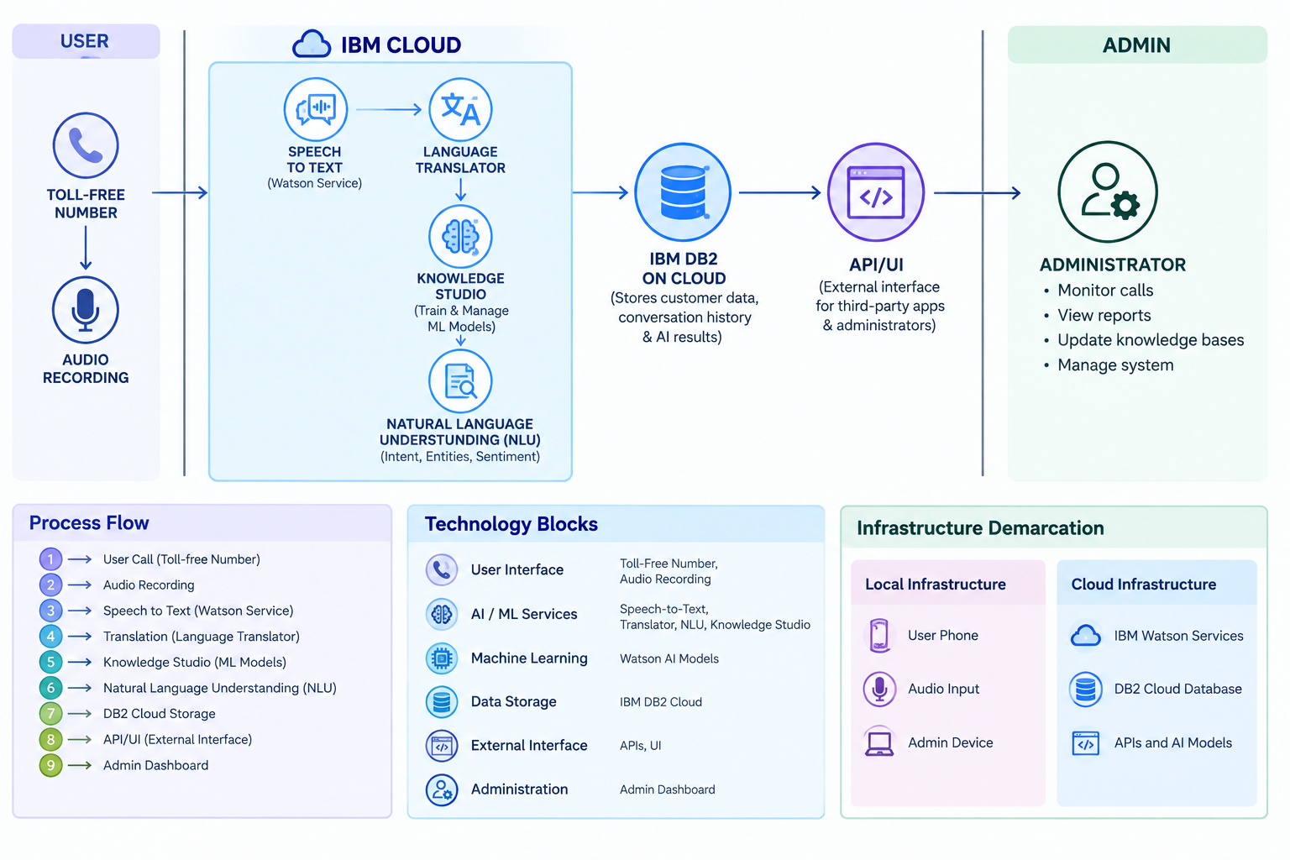

Table-1 : Components & Technologies:

S.No | Component | Description | Technology
 | User Interface | Allows users to interact with the application through voice input and the admin interface. | HTML, CSS, JavaScript
2. | Application Logic-1 | Handles application processing, data flow and communication between the user interface and cloud services. | Java / Python
3. | Application Logic-2 | Converts the user's recorded speech into text. | IBM Watson STT service
4. | Application Logic-3 | Translates the converted text into the required language. | IBM Watson Assistant
5. | Database | Stores and manages application-related structured data. | MySQL, NoSQL, etc.
6. | Cloud Database | Stores customer information, conversation history and AI-related results in the cloud. | IBM DB2, IBM Cloudant etc.
7. | File Storage | Stores audio or other files temporarily when required. | IBM Block Storage or Other Storage Service or Local File system
8. | External API-1 | Provides speech recognition functionality through an external cloud API. | IBM Weather API, etc.
9. | External API-2 | Provides language translation functionality through an external cloud API. | Aadhar API, etc.
10. | Machine Learning Model | Understands user language, identifies intent and extracts important information from text. | Object Recognition Model, etc.
11. | Infrastructure (Server / Cloud) | Provides the environment for deploying and running the application and AI services. | Local, Cloud Foundry, Kubernetes, etc.

Table-2: Application Characteristics:

S.No | Characteristics | Description | Technology
 | Open-Source Frameworks | Open-source technologies are used to develop the application interface and application logic. | HTML, CSS, JavaScript, Python
2. | Security Implementations | Protects user data and controls access to cloud resources and APIs. | IBM Cloud IAM, HTTPS/TLS, API authentication.
3. | Scalable Architecture | Cloud-based AI services and database services can support increasing users and requests. | IBM Cloud, Watson Services, Db2 Cloud
4. | Availability | Cloud-managed services provide reliable access to AI processing and database services. | IBM Cloud, Watson Services, Db2 Cloud
5. | Performance | Cloud AI services process speech and text efficiently, while database storage supports quick data access. | IBM Watson Services, Db2 Cloud, Python

References
- C4 Model – Software Architecture
- https://developer.ibm.com/patterns/online-order-processing-system-during-pandemic/
- IBM Cloud – Architecture
- AWS Architecture Center
- Medium – How to Draw Useful Technical Architecture Diagrams

